**MODULE-4**

**PROJECT MANAGEMENT**

**Project:**

* Project in general refers to a new endeavor with specific objective and varies so widely that it is very difficult to precisely define it. Some of the commonly quoted definitions are as follows.
* Project is a temporary endeavor undertaken to create a unique product or service or result.

**Project Characteristics :**

Despite diversities, projects share the following common characteristics.

* Unique in nature.
* Have definite objectives (goals) to achieve.
* Requires set of resources.
* Have a specific time frame for completion with a definite start and finish.
* Involves risk and uncertainty.
* Requires cross-functional teams and interdisciplinary approach.

**Project Management:**

* Project management is about managing projects, and it helps projects achieve their objectives.
* The processes include initiating the project, developing a plan, executing the project, controlling the project activities throughout its lifetime, and finally handing over the output of the project to the client, and closing the project.
* Project management is the application of knowledge, skills, tools, and techniques to meet project requirements.

**Benefits of Project Management:**

* Project management approach will help in handling complex, costly and risky assignments by providing interdisciplinary approach in handling the assignments. Example: R&D organizations.
* Project management approaches help in handling assignments in a specified time frame with definite start and completion points. Example handling customer orders by Industries involved in production of capital goods.
* Project management approaches provide task orientation to personnel in an Organization in handling assignments. Example Organizations in IT sector handling software development assignments for clients.

**Program Management:**

* Programs are managed under program management, which is defined as the centralized, coordinated management of a program to achieve its strategic objectives.
* You only manage the interrelated or similar projects as a group to accomplish the desired result.
* The objective of program management is to optimize the resource utilization among projects and reduce the friction to increase the organization’s performance

**Benefits of Program Management**

•Less conflict among projects

•Optimal utilization of resources

•Resource constraints are minimized

•Better communication and coordination among projects

•Improved organizational performance

**Portfolio Management:**

* A portfolio is **a collection of financial investments like stocks, bonds, commodities, cash, and cash equivalents**, including closed-end funds and exchange traded funds (ETFs).
* Portfolios are managed under portfolio management. It has a bigger scope and objective than program management.
* There is centralized management in portfolio management, that individual’s job is to identify, prioritize, and authorize the projects or programs.
* This centralized management manages the projects or programs to achieve the organization’s strategic objectives.
* Portfolio managers set the priorities of projects based on the leadership’s agreed-upon business objectives. They select the program or projects under a particular portfolio and make sure that they provide the most benefit to the organization.

**The Difference Between Portfolio Management and Program Management :**

• Program management manages similar projects while portfolio management manages dissimilar projects or programs.

• The scope of program management is broader than the project scope, and a portfolio has an organization-wide scope, which changes with the strategic objectives of the organization.

**The Benefits of Portfolio Management**

* Optimal allocation and utilization of resources among projects or programs
* Constant support to projects or programs
* Fewer conflicts and better communication among projects or programs
* Better coordination among projects or programs

**Phases in Project Life Cycle:**

* Every project, from conception to completion, passes through various phases of a life cycle synonym to life cycle of living beings.
* There is no universal consensus on the number of   
  phases in a project cycle.
* An understanding of the life cycle is important to successful completion of the project as it facilitates to understand the logical sequence of events in the continuum of progress from start to finish.
* Typical project consists of four phases- Conceptualization, Planning Execution and Termination.
* 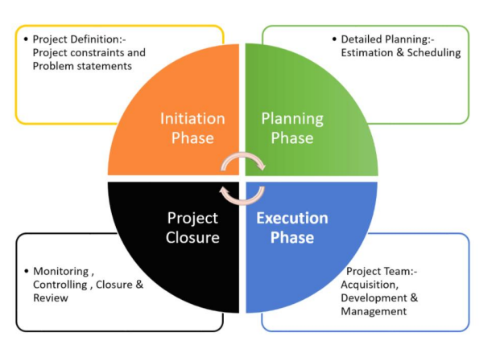Each phase is marked by one or more deliverables such as Concept note, Feasibility report, Implementation Plan, HRD plan, Resource allocation plan, Evaluation report etc.

**Conceptualization Phase**

* Conception phase, starting with the seed of an idea, it covers identification of the product / service, Pre-feasibility, Feasibility studies and Appraisal and Approval.
* The project idea is conceptualized with initial considerations of all possible alternatives for achieving the project objectives.
* As the idea becomes established a proposal is developed setting out rationale, method, estimated costs, benefits and other details for appraisal of the stakeholders.
* After reaching a broad consensus on the proposal the feasibility dimensions are analyzed in detail.

**Planning Phase**

* In this phase the project structure is planned based on project appraisal and approvals.
* Detailed plans for activity, finance, and resources are developed and integrated to the quality parameters.
* In the process major tasks need to be performed in this phase are
* Identification of activities and their sequencing
* Time frame for execution Estimation and budgeting
* Staffing A Detailed Project Report (DPR) specifying various aspects of the project is finalized to facilitate execution in this phase.

**Execution Phase**

* This phase of the project witnesses the concentrated activity where the plans are put into operation.
* Each activity is monitored, controlled and coordinated to achieve project objectives.
* Important activities in this phase are
* Communicating with stakeholders reviewing progress
* Monitoring cost and time
* Controlling quality
* Managing changes

**Termination Phase**

* This phase marks the completion of the project wherein the agreed deliverables are installed and project is put in to operation with arrangements for follow-up and evaluation.

**Top Down and Bottoms up Estimation:**

* The Top-down approach is practical for the initial stage of strategic decision-making and in situations where the information required to develop accurate duration and costs estimates is not available in the initial phase of the project
* Delphi (Consensus) Method: Uses the pooled experiences of senior and/or middle managers to discuss thoroughly and ultimately reach an agreement of best estimate of the total project duration and costs in the initial stage.
* Apportionment (analogous) technique: Uses good historical data of past projects that are relatively standard with minor variation or customization as a reference to allocate duration and costs to the current project
* Apportionment (analogous) technique: Example: Assuming the total project costs of a standardized product is estimated using a top-down approach to be $500,000, the costs of each top project deliverable are apportioned as a percentage of the total project cost as follows:
* Total Project Costs: $500,000
* Design Cost: 25% = $125,000
* Engineering Cost: 25% = $125,000
* Test Cost: 20% = $100,000
* Documentation Cost: 10% = $50,000
* Produce Goods Cost: 20% = $100,000

**The Bottom-up approach** is typically more reliable and preferred for estimating because it assesses each work package from the bottom, working up to a deliverable and phase.

* It is practical to use when project schedules and budget from previous similar projects are available for reference.
* Estimating duration and costs for each work package facilitates the development of schedules and a time-phased budget, which are required to monitor and control the project as it progresses.

**Template Method** The schedules and budget from past projects of similar starts but with different endings can be used as a starting point for the new project.

* For example, an engineering services company has different sets of standard templates for different equipment repair and site maintenance projects.

**WBS- Work Breakdown Structure:**

* Breaking work into smaller tasks is a common productivity technique used to make the work more manageable and approachable.
* For projects, the Work Breakdown Structure (WBS) is the tool that utilizes this technique and is one of the most important project management documents.
* It single handedly integrates scope, cost and schedule baselines ensuring that project plans are in alignment.
* There are two types of WBS: 1) Deliverable-Based and 2) Phase-Based.
* A well-constructed work breakdown structure helps with important [project management process groups](https://www.projectmanager.com/blog/project-management-process-groups) and knowledge areas such as:
* Project Planning, Project Scheduling and Project Budgeting
* Risk Management, Resource Management, Task Management and Team Management
* In addition, a WBS helps avoid common [project management](https://www.projectmanager.com/project-management) issues such as missed deadlines, scope creep and cost overrun, among others.
* All the steps of project work are outlined in the work breakdown structure chart, which makes it an essential project planning tool.
* The final project deliverable, as well as the tasks and work packages associated with it rest on top of the WBS diagram, and the WBS levels below subdivide the project scope to indicate the tasks, deliverables and work packages that are needed to complete the project from start to finish.

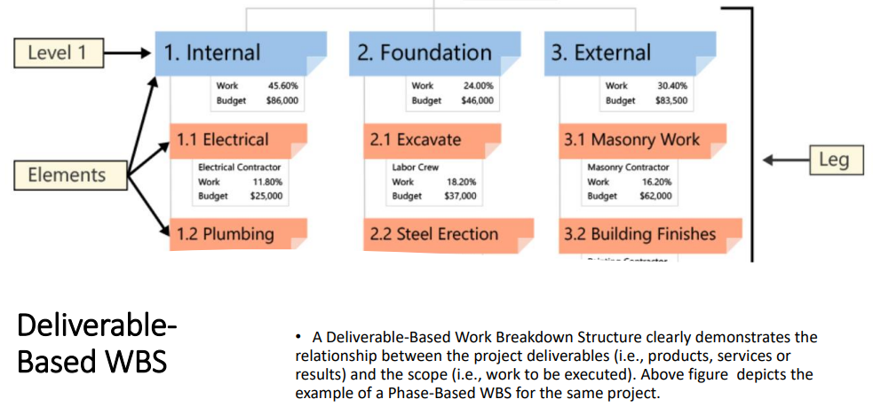

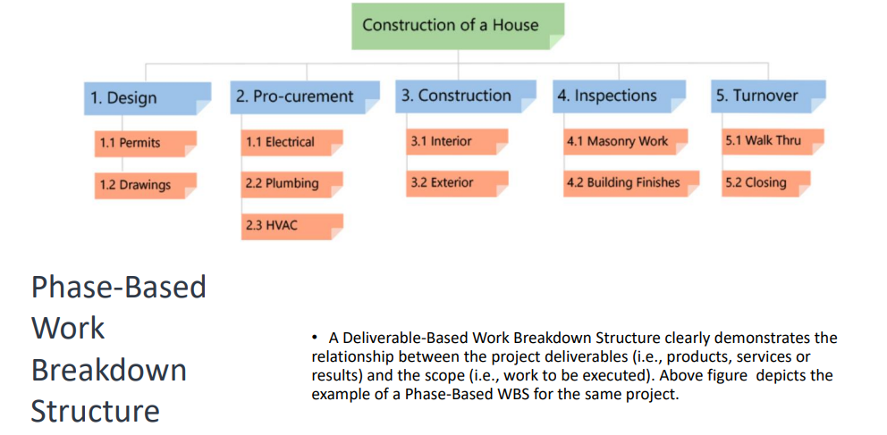

**Stakeholder Management:**

* A stakeholder is someone who has an interest in or who is affected by your project and its outcome.
* This may include both internal and external entities such as the members of the project team, project sponsors, executives, customers, suppliers, partners and the government.
* Stakeholder management is the process of managing the expectations and the requirements of these stakeholders.
* It involves identifying and analyzing stakeholders and systematically planning to communicate and engaging with them

**Stakeholder Management Process:**

* **Stakeholder Identification**
* First step is to identify stakeholders of your project. You can start by listing down anyone and everyone who is affected by the project.
* You don’t need to worry about assigning them a category yet; simply jot down their name or their company to specify. Stakeholders who you should take into consideration are those
* Who will be affected (positively and negatively) by your project
* Who has an interest in your project
* Who has power over your project
* Who wants your project to fail
* Who wants your project to be successful
* **Stakeholder Analysis**
* In this step you will be evaluating the stakeholders in terms of the power and interest they have over your project. By categorizing them thus, you can decide which stakeholders you should spend most and least effort on.
* **The Power Interest Grid**
* The Power Interest grid is the most widely used technique in stakeholder analysis. This tool helps you determine what you will communicate to your stakeholders and how often you will do so.

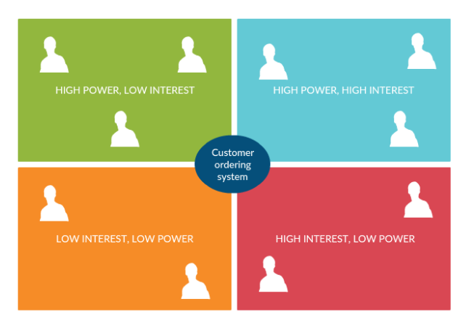

* **High Power/ High Interest (Fully Engage)**
* The stakeholders you place on this quadrant are the key players. While you will have to spend the most effort on engaging with them, you should keep them informed at all times.
* **High Power/ Low Interest (Keep Satisfied)**
* Make enough effort to keep these stakeholders satisfied. But refrain from going overboard with your communication efforts lest you make them bored.
* **Low Power/ High Interest ( Keep Informed)**
* Provide adequate information on the project to these people and ensure that they don’t have any issues with the project.
* **Low Power/ Low Interest (Minimum Effort)**
* Monitor these stakeholders and their interest in the project and provide them with adequate information without overloading them.

**Stakeholder SWOT Analysis:**

* Great tool to analyze the importance of your stakeholders and prioritize them is the SWOT analysis.
* With it you can evaluate your stakeholders based on their strengths and weaknesses, threats they pose to your project and the opportunities they can bring to successfully complete the project.

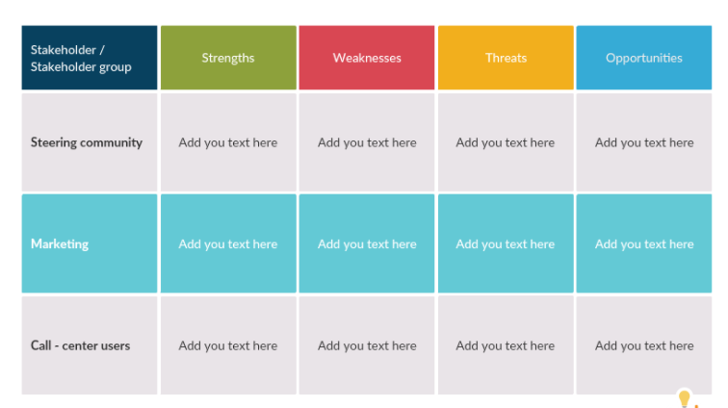

**Identification of New Ideas:**

* The objective is to identify investment opportunities which are feasible and promising.
* An idea regarding a required intervention in a specific area to address identified problem is formed and developed.
* This idea is usually hatched through discussions by specialists and local leaders in a community need based on issues and turned into a proposal.
* Project ideas are generated depending on:
* Consumer needs
* Market demand
* Resource availability
* Technology
* Natural calamity
* SWOT analysis
* Political considerations etc.
* A project idea should be SMART:
* S – Specific objective
* M – Measurable
* A – Achievable
* R – Realistic
* T – Time bounded
* Sources of project ideas can be categorized into two :
* **Micro level sources**
* Analysis of the performance of existing industries
* A study of existing industries in terms of their profitability utilization can indicate promoting investment opportunities which are profitable and relatively risk free.
* An examination of capacity utilization of various industries provides information about the potential for further investments.
* Such study is more useful if it is done region wise. Particularly for products which have high demand for consumption and wide scope for production
* **Examination of the input-outputs of various industries**
* The analysis of inputs required for various industries may throw some project ideas.
* Opportunities exist when Materials, purchased parts, or supplies are presently procured from distance sources with considerable time lag and transportation cost.
* Several firms produce internally some components parts which can be supplied at lower cost by a single producer who can enjoy economics of scale.
* **Review of imports and exports**
* Analysis of import statistics for a period of five to seven years is helpful in understanding the trend of imports of various goods and the potential for import substitution.
* Indigenous manufacture of goods currently imported is advantageous for several reasons.
* It improves the balance of payments situation.
* It generates employment, and it provides market for the supporting industries and services.
* Likewise, an examination of export statistics is useful in learning about the export possibilities of various products.
* **Investigation of local materials and resources**
* A search for project ideas may begin an investigation into local resources and skills.
* Various ways of adding value to locally available materials may be examined.
* The skills of local artisans may suggest products that might be profitably produced and marketed.
* Such assessment may consider issues such as the human and material resources, Infrastructure facilities and market for various products.
* **Analysis of economic and social changes:**
* A study of economic and social trends is helpful in projecting demands for various goods and services.
* Changing economic conditions and consumer preferences provide new businesses opportunities. For example a greater awareness of the value of time is dawning on public. Hence the demand for time saving products like prepared food items, ovens and powered vehicles has been increasing.
* The other change that can be seen during analysis is the increasing desire for the leisure and recreational activities. This has caused a growth in the market for recreational products and services.
* **Study of new technological developments:**
* New products are the new process and technologies for existing products developed by the research laboratories may be examined for profitable communication
* **Attending trade fairs:**
* National and international trade fairs provide an excellent opportunity to know about new product and developments.
* **Macro Level**
* **Project ideas from government policies and plan**
* From time to time governments produce guidelines such as the national development plans and session papers which spell out the directions the government should take to achieve certain targets in various sectors of the economy and guidelines to various organizations and individuals.
* The information contained in these documents is useful in generating ideas for new projects for Ex: If the government intends to start number of new schools in a given area then a number of projects which of related to the establishment such schools would be considered.
* **Project ideas from technical specifications:**
* For many industrial projects, ideas will usually tend to come from technical specifications, which by virtue of their experience and for research findings will give use full information which may lead to the manufacturing of new products or improving the existing products.

**Alternative Analysis:**

* **“There’s more than one way to skin a cat”**
* An alternative analysis is the evaluation of the various routes you can pursue to achieve the goal of a project or a particular project management objective.
* It looks beyond the status quo to compare different ways of getting work done.
* These factors can be operational, such as cost, risk and effectiveness, as well as the potential shortfalls of those operational factors.
* To perform an alternative analysis, tools such as life-cycle costing, sensitivity analysis, cash flow analysis and cost-benefit analysis are used.
* Analysis of alternatives, also called AOA, is part of the decision-making process when looking at existing portfolios, programs and projects or while initiating a new project. This decision-making process helps to find cost-effective actions and avoid unnecessary effort duplication. Using AOA will help reduce the risk of project failure.
* **Sensitivity analysis** is the quantitative risk assessment of how changes in a specific model variable impacts the output of the model.
* Often referred to as a Tornado chart, sensitivity analysis shows which task variables (Cost, Start and Finish Times, Duration, etc) have the greatest impact on project parameters
* **Spearman Rank Order Method**
* For schedule risk analysis, Spearman rank order is a statistical method that generates a correlation coefficient from 0 to +1 where a score of 1 is a perfect correlation between the input and the output. In other words, it measures the strength of the relationship between the input and output variables. For example, you would like to know how the changes in the cost of a particular material impacts the overall cost of a project and identify those which cause the greatest variance in the projects.

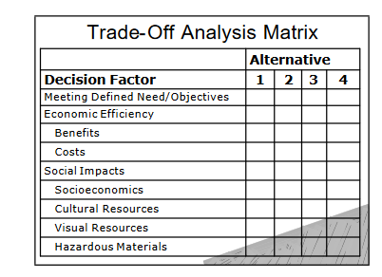

**When Should Alternative Analysis Be Used in Project Management?:**

* Alternative analysis is used whenever a solution is needed. When decision-makers are in the decision-making process, they want to know the best course for moving forward.
* An AOA is typically done at the initiation of a project, but is also used throughout the life cycle of the project.
* It’s one way to determine if the decision-making process is sound. Making updates throughout the process will refine the solution and reaffirm the assessment criteria.

**Benefits of Analysis of alternatives (AOA):**

* Using an analysis of alternatives (AOA) will help the project, portfolio and program managers identify, understand and evaluate the alternatives open to them when managing a project.
* It will also help them to select the best course of action as it concerns project costs and risks.
* By looking at alternatives, decision-makers have more data to make an informed choice with.

**How to Execute an Alternative Analysis?:**

* **Make a Plan**
* The first thing to do is make a plan. This means defining the various decisions that you can make to meet your objective and achieve operational effectiveness.
* You’ll want to include stakeholders, but also define the timing, effort or costs involved.
* There will need to be a study team assembled and a study plan to direct their activities.
* **Organize the Analytic Framework**
* The next step is to define the analysis problem statement, the context of the problem, scope and a framework for alternative comparisons.
* This includes the comparison criteria to be used. Frame the analysis with the ground rules , including any assumptions you might have.
* **Identify and Define Alternatives**
* Next identify the various alternative routes you can take from the data sources.
* There will be many, but be sure to keep one as the status quo.
* These alternatives will address the problem you stated in your plan within the context and scope you’ve already defined.
* The alternatives you evaluate must come out of thorough research, and filtering before you can begin the decision-making process.
* **Assess the Alternatives**
* Look over each of the alternatives you’ve come up with.
* Evaluate them against your established criteria, such as cost, risk, life cycle cost-effectiveness, benefits and likelihood analysis.
* conduct a sensitivity analysis, which is a financial model that looks at a target variable and how it is impacted by changes from input variables
* **Compare the Alternatives**
* Weigh the pros and cons of the various alternatives you’ve identified.
* Determine what the merits of each are, as shown by the analysis you’ve made.
* **Report the Results**
* Finally, you’ll want to document the results of the AOA to show the life cycle cost that supports the alternative or status quo you chose, and how that will support the project decision-makers and/or stakeholder needs.